**Meeting Minutes [6]**

Date: 10 April 2021

Time: 22:00 PM to 00:00 PM

Location: zoom and figma

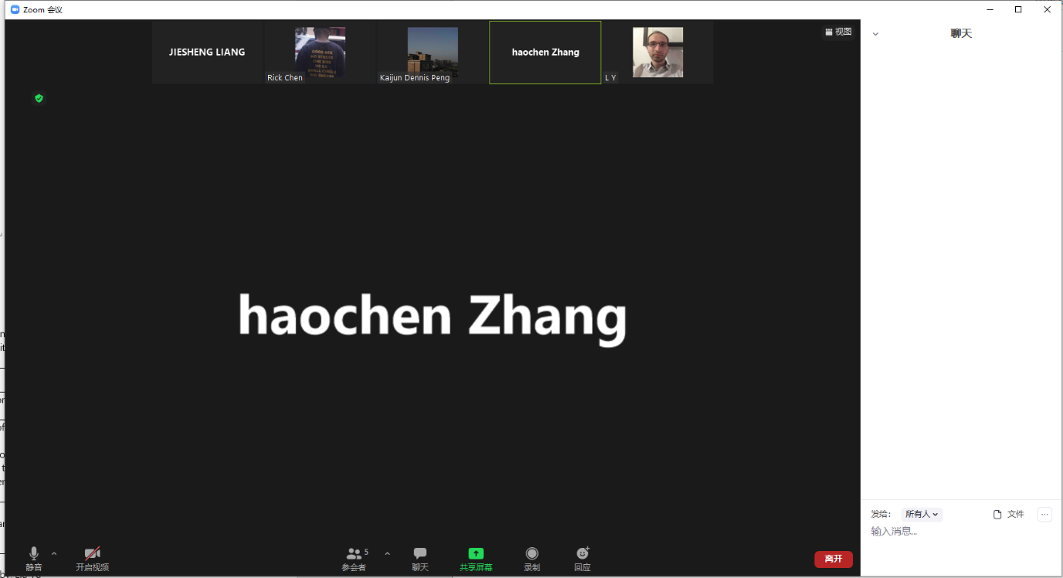

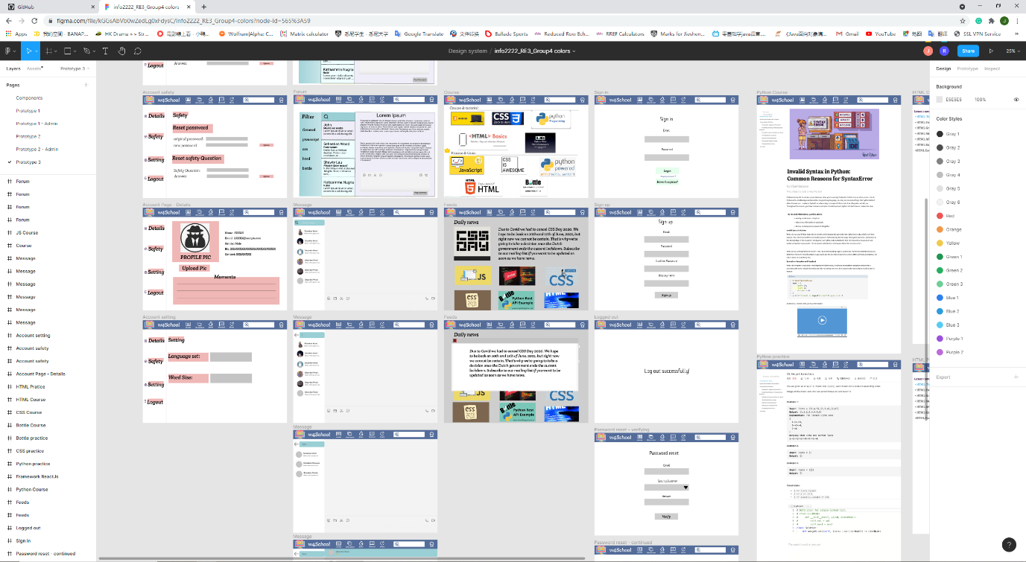

Members present:

* Jiesheng(Jackson) Liang
* Kaijun(Dennis) Peng
* Liu Yu
* Haochen zhang
* Bingyan chen

Agenda:

* Task 6: Implement the improved design from task 5.
* Discuss: Evaluate the usability

|  |  |  |  |
| --- | --- | --- | --- |
| No. | Items | Presenter | Action by |
| 1. | According to second time’s user evaluation, iterative design-third version prototype, sum up conducted user evaluations. | All the members | All the members |
| 2. | Before next meeting:  Everyone should prepare for demonstration. | All the members | All the members |

Minutes prepared and recorded by: JIESHENG(Jackson) LIANG

Confirmed by: Rick Chen, Kaijun (Dennis) Peng, Jiesheng (Jackson) Liang, Liu Yu, Haochen zhang